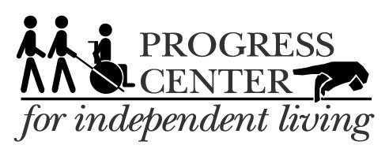

**March with Pride!**

7521 Madison Street, Forest Park IL 60130 12940 S. Western Av., 3rd Floor, Blue Island IL 60406

V: 708.209-1500 VRS: 708.689-1378 V: 708.388-5011

### 

### 14th Annual Disability Pride Parade Love is Disability Pride

### July 22, 2017

March with Progress Center for Independent Living!

Parade starts at 11am

Arrive at 10am

Lineup at

401 S. Plymouth Ct, Chicago, IL

**If you want to march with Progress Center, contact…**

**Rhychell Barnes <**[**rbarnes@progresscil.org**](mailto:rbarnes@progresscil.org)**>, 708-689-1381.**



**\*ACCESSIBILITY:** We respectfully ask that guests wear NO scented products. Thank you.