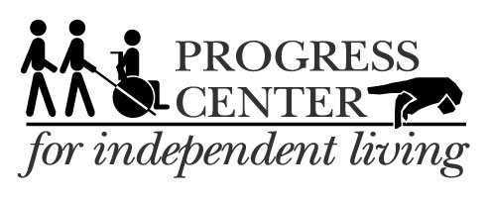

**June 2017**

7521 Madison St., Forest Park IL 60130

Phone: 708-209-1500; VP: 708-689-1378

2940 S. Western Ave., 3rd Floor, Blue Island IL 60406

Phone: 708-388-5011

Check website for updates: http://www.ProgressCIL.org

**“Nothing About Us, Without Us"**

**Progress Center for Independent Living presents “70’s & 80’s Boogie Nite”**

****Come party with us! June 16th, 6:00 pm – 8 pm at the main office, to sign up for an act or register a seat contact Tanya @ 708-209-1500 xt 18

**ITAC:** Are you or someone you know having difficulty hearing or use a hearing device? You may qualify for a Free Amplified Phone or cellphone amplifier for more information contact Marie today at (708) 209-1500

**Progress Center for Independent Living’s 29th Annual Meeting**

Will be held at the Calumet Park Senior Community Center in Calumet Park, IL on Saturday June 24th from 11:00 AM – 3:00 PM. If you would like to attend or need more information please contact Clark Craig at (708)209-1500 x34

**Train-the-Trainers:** Accessibility survey training at local businesses designed to help consumers advocate with Federal, State and local politicians to improve services for people with disabilities. Two sessions beginning June 8th, and June 15th at PCIL main to sign up, call Larry Biondi at (708) 209-1500. xt 24

**Membership & Outreach Committee:** Will meet June 21st from 2:00-4pm at our Forest Park office. Please sign up ahead with Clark Craig x34: (708) 209-1500



**ASL Training** Classes begin June 2nd once a week on Friday’s from 2-4 PM in the community room at our Forest Park office. Call Rhychell at (708) 689-1381

**Stepping Stones**: Independent living Skills training classes for people in nursing homes that are interested in transitioning back into the community and/or would like to learn the skills to maintain their current level of independence. Contact Art x21 or Tonya x18 at 708-209-1500 for more information

_____________________________________________________________

[](http://www.scentaware.com/about-scent-free/)**ACCESSIBILITY:** Progress Center is accessible. Please call ahead for reasonable accommodations. Please do not wear scented products.