Train-the-Trainers

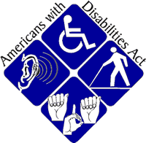

PEOPLE WITH DISABILITIES HAVE MONEY TO SHOP AND SHOULD HAVE THE ACCESSIBILITY TO DO SO!!
Join us on June 8th and June 15th for the Train-the-Trainers event held at the Progress Center for Independent Living main office. This training event will provide consumers with the necessary skills and knowledge to properly perform ADA accessibility surveys at businesses within their communities and surrounding areas. The Train-the-Trainer sessions are currently being offered during the month of June. You don’t want to miss this event!!

Thursdays, June 8th & June 15th 1:00 PM – 4:00 PM
Call to register your spot today! (708) 209-1500
Ask for Larry

