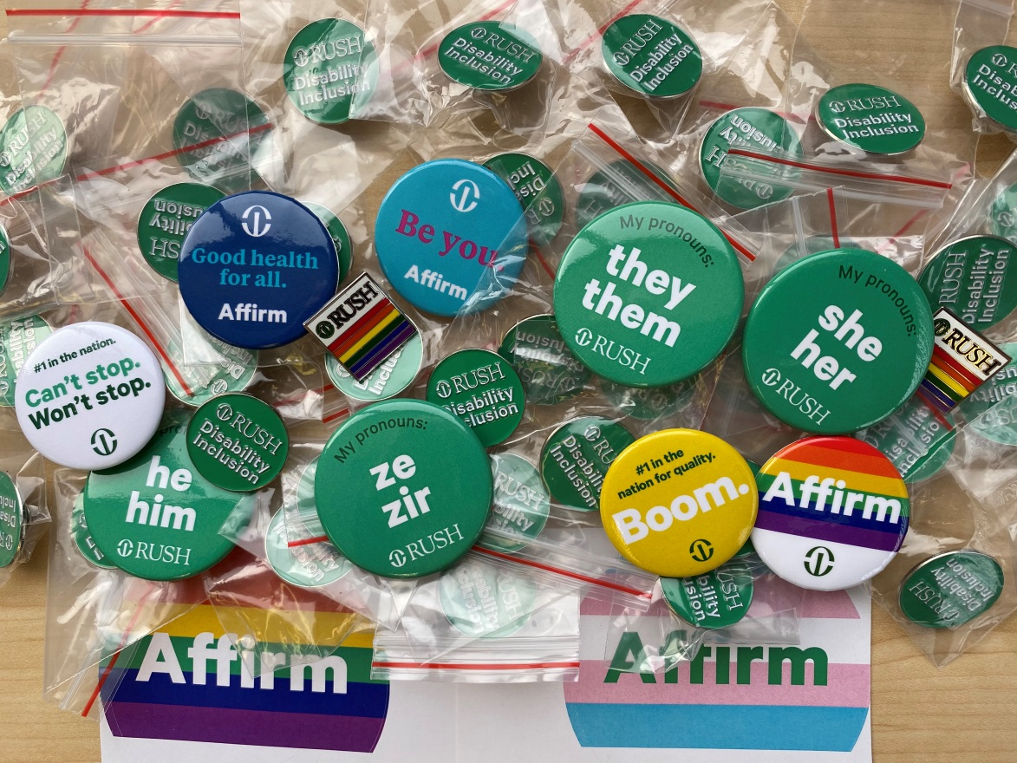

Disability Disclosure During the Job Search – Resources and Related Links
Kevin Irvine, Senior Talent Acquisition Consultant, Individuals with Disabilities
Rush University Medical Center
My Pronouns: he/him/his
My Disabilities: HIV, Hemophilia B
Kevin_Irvine@rush.edu
https://www.linkedin.com/in/kevinirvinechi/
“When we speak we are afraid our words will not be heard or welcomed. But when we are silent, we are still afraid. So it is better to speak.” – Audre Lorde
“The visibility which makes us most vulnerable is that which is also the source of our greatest strength.”- Audre Lorde
Helpful Resources:
Discover job opportunities at Rush University Medical Center, in Chicago, Rush Oak Park Hospital, and Rush Copley Medical Center, in Aurora: https://www.rush.edu/careers/apply-position-rush (Pro tip: For RUMC job postings, always check the “New This Week” category!)
Learn about Rush’s Culture of Inclusion: https://www.rush.edu/careers/culture-inclusion
Disability Inclusion at Rush: https://www.rush.edu/careers/culture-inclusion/people-disabilities
Veterans at Rush: https://www.rush.edu/careers/culture-inclusion/veterans-rush
Commitment to LGBTQ+ Health Care at Rush, which also supports the #HireTransNOW campaign: https://www.rush.edu/about-us/diversity-equity-and-inclusion/commitment-lgbtq-health-care
Rush Resources for Job Seekers: https://www.rush.edu/careers/resources-job-seekers
Volunteering at Rush: https://www.rush.edu/giving/about/volunteer
Rush's Anchor Mission Strategy – As an anchor institution on the West Side of Chicago, Rush University Medical Center has a responsibility to use its economic power to bring systemic change. Learn more here: https://www.rush.edu/about-us/rush-community/rushs-anchor-mission-strategy
Self-Disclosure and Its Impact on People Who Receive Mental Health Services: https://store.samhsa.gov/sites/default/files/d7/priv/sma08-4337.pdf
When Your Employee Discloses a Mental Health Condition: https://hbr.org/2021/02/when-your-employee-discloses-a-mental-health-condition?utm_medium=email&utm_source=newsletter_weekly&utm_campaign=weeklyhotlist_not_activesubs&deliveryName=DM121233
Section 503 of the Rehabilitation Act Fact Sheet: https://adata.org/sites/adata.org/files/files/Section%20503%20RA%20New%20Rules%20Fact%20Sheet%20Final%20NEW%20FORMAT%201-14(1).pdf
Disability:IN Best Places to Work for Disability Inclusion: https://disabilityin.org/what-we-do/disability-equality-index/2020companies/
Why disclose a disability to an employer? The practice of disability pride: https://medium.com/disability-power-and-influence/the-practice-of-disability-pride-f06dc4a79eba
How Disability Pride Fights Ableism: https://www.psychologytoday.com/us/blog/disability-is-diversity/202008/how-disability-pride-fights-ableism
What is Disability Identity Development, and Why is That Important? https://www.tennesseeworks.org/what-is-disability-identity-development-and-why-is-that-important/
EEOC guidance – Disability Discrimination & the ADA: https://www.eeoc.gov/disability-discrimination
EEOC guidance – Your Employment Rights as an Individual with a Disability: https://www.eeoc.gov/laws/guidance/your-employment-rights-individual-disability
Job Accommodation Network info on various disabilities, impairments, and conditions: https://askjan.org/a-to-z.cfm
EARN – Employer Assistance and Resource Network on Disability Inclusion – Encouraging Self-Identification: https://askearn.org/topics/federal-contractor-requirements/encouraging-self-identification/
Do Ask, Do Tell - Encouraging Employees with Disabilities to Self-Identify: https://askearn.org/wp-content/uploads/docs/do_ask_do_tell.pdf
Job Accommodation Network - Affirmative Action and Disability – What Can Employers Ask? https://askjan.org/publications/consultants-corner/vol05iss05.cfm
COVID-19 and Job Applicants and Employees with Disabilities – Emerging Practices to Employ and Protect Workers: https://askearn.org/wp-content/uploads/2020/08/EARN_2020_Covid19-PolicyBrief.pdf
Fostering Disability-Inclusive Workplaces Through Employee Resource Groups: https://askearn.org/wp-content/uploads/2019/06/EARN_ERG_Fact_Sheet-A.pdf
In October 2020, members of Rush’s Disabilities Employee Resource Group presented a webinar on Invisible Disabilities in the Workplace. We hope to have the recording of the panel on our YouTube channel soon, but for now you should be able to view it here: https://rush.zoom.us/rec/play/_wZIyzNySP7NJ0QLff2TI0W3DmqLvtBCrIv_dSiK5j-UAUa8UFKMw50vv3YiVbYrt7gLaf3rREwzx6BR.DAphoUf7zQoufsxG?startTime=1603386139000&_x_zm_rtaid=KrYiPqImR2yQr95zXD4xqg.1603727252344.56f1a2944c77ad01d172e00d7e1713b4&_x_zm_rhtaid=926
Article about clear masks at Rush that features some of our disabled employees who have hearing loss: https://www.rush.edu/news/making-communication-clearer-during-covid-19

