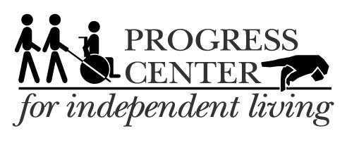

**APRIL 2017**

7521 Madison St., Forest Park IL 60130

Phone: 708-209-1500; VP: 708-689-1378

2940 S. Western Ave., 3rd Floor, Blue Island IL 60406

Phone: 708-388-5011

Check website for updates: http://www.ProgressCIL.org

**“Nothing About Us, Without Us"**

**Progress Center for Independent Living presents “Karaoke Night”**

If you think you’ve got what it takes to sing or you just want to have some fun then come party with us! April 21st 6:00 pm – 8 pm at the main office, to sign up for an act or register a seat contact Tanya @ 708-209-1500 xt 18

******ITAC:** Are you or someone you know having difficulty hearing or use a hearing device? You may qualify for a Free Amplified Phone. Contact Marie today at (708) 209-1500

**Stepping Stones:** Community Reintegration Classes for people with disabilities that have moved out of Nursing Institutions and/or would like to transition back into the community. Classes will Begin in March!! For more information or to register a spot contact Art xt 21 or Tanya xt 18: (708) 209-1500

**Legislative Advocacy Training:** Designed to help consumers advocate with Federal, State and local politicians to improve services for people with disabilities. Starting April 4th, 10 week class, to sign up, call Larry Biondi at (708) 209-1500. xt 24

**Membership & Outreach Committee:** Will meet April 19th from 2:30-4pm at our Forest Park office. Please sign up ahead with Clark Craig: (708) 209-1500. xt 34

**Job Seekers Club** Classes begin March 16 – June 1 and are held once a week on Thursday’s from 1-3 PM in the community room at our Forest Park office. Call Sarah at (708) 209-1500 xt 39

**Budget Training Classes**: Contact Carol or Rhychell at (708) 209-1500 to sign up. Classes are held every Wednesday at main office beginning April, 5th from 1:00 pm – 3:00 pm

____________________________________________________________________

[](http://www.scentaware.com/about-scent-free/)**ACCESSIBILITY:** Progress Center is accessible. Please call ahead for reasonable accommodations. Please do not wear scented products.